CANTEEN TOKEN MANAGEMENT SYSTEM

A MINI PROJECT REPORT
Submitted by
ADARSH JAYACHANDRAN(TKR19CS002)
ALVIN ANTONY(TKR19CS006)
FALILU RAHMAN(TKR19CS020)
SANJAY K V(LTKR19CS055)

to
the APJ Abdul Kalam Technological University in partial fulfilment of the requirements for the award of the Degree
of
Bachelor of
Technology in
Computer Science


Department of Computer Science Engineering
College of Engineering
Trikaripur
DECLARATION

We undersigned hereby declare that the project report ”Canteen Token Management
System”, submitted for partial fulfillment of the requirements for the award of degree of
Bachelor of Technology of the APJ Abdul Kalam Technological University, Kerala is a
bonafide work done by me under supervision of Shabna Salam, Assistant Professor
Department of CS. This submission represents my ideas in my own words and where ideas or
words of others have been included, I have adequately and accurately cited and referenced
the original sources. I also declare that I have adhered to ethics of academic honesty and
integrity and have not misrepresented or fabricated any data or idea or fact or source in my
submission. I understand that any violation of the above will be a cause for disciplinary
action by the institute and/or the University and can also evoke penal action from the sources
which have thus not been properly cited or from whom proper permission has not been
obtained. This report has not been previously formed the basis for the award of any degree,
diploma or similar title of any other University.

Place Signature

DEPARTMENT OF COMPUTER SCIENCE ENGINEERING
COLLEGE OF ENGINEERING ,TRIKARIPUR



CERTIFICATE

This is to certify that the report entitled ”CANTEEN TOKEN MANAGEMENT SYSTEM”, submitted by Adarsh Jayachandran,Falilu Rahman,Alvin Antony,Sanjay K Vto the APJ Abdul Kalam Technological University in partial fulfillment of the requirements for the award of the Degree of Bachelor of Technology in Computer Science is a bonafide record of the seminar carried out by him/her under my guidance and supervision. This report in any form has not been submitted to any other University or Institute for any purpose.

Internal Supervisor(s) External Supervisor(s)

PG Coordinator Head of the Department

ACKNOWLEDGEMENT

We give honour and praise to the LORD who gave us wisdom and enabled us to complete this mini project successfully.
We would like to thank the Department of Computer Science Engineering, College of Engineering Trikaripur , for giving us the opportunity to present this seminar.
We would like to express our deep gratitude to our Co-ordinator Sreeraj S for his timely suggestions and encouragement through the processes involved in the presentation of the seminar for his wholehearted support and encouragement for the betterment of the seminar presentation and report preparation.
Last, but not the least, we express our heartfelt thanks to our friends and parents for their support and encouragement during this endeavour.

ABSTRACT

Generate a virtual token before visiting the canteen of our College. Enables Students to pay for Canteen food on mobile. Receives electronic tokens, updates on the status in Food along with expected wait times, currently serving token number and other details on mobile. No longer need to waste your precious time waiting in line for Food. With Online Token, Students can get tokens seamlessly, and business owners can track and handle students queues smartly and make the most of every students visit by reducing walk-aways.

CONTENTS

- ABSTRACT 5
- LIST OF FIGURES 7
- ABBREVIATIONS 8
- CHAPTER 1: INTRODUCTION 9
  - BACKGROUND 9
  - SCOPE 10
  - OBJECTIVE 10
  - PROPOSED SYSTEM 10
- CHAPTER 2:SRS 11
2.1 PRODUCT OVERVIEW 11
2.2 PRODUCT FUNCTIONALITY 12
2.3 DESIGN AND IMPLEMENTATION CONSTRAINTS 13
2.4 HARDWARE REQUIREMENTS 13
2.5 SOFTWARE REQUIREMENTS 14
2.6 FUNCTIONAL REQUIREMENTS 14
- CHAPTER 3:MATERIAL AND METHODS 15
3.1 DESIGN PHASE 15
3.2 DATA FLOW DIAGRAM 16
3.3 ACTIVITY DIAGRAM 19
3.4 USE CASE DIAGRAM 21
3.5 DATABASE DESIGN 23
- CHAPTER 4:IMPLEMENTATION 25
- CHAPTER 5:RESULTS AND DISCUSSIONS 29
- CHAPTER 6:CONCLUSION 30
- BIBLIOGRAPHY 31
LIST OF FIGURES

3.2 Data Flow Diagram………………………………...16
3.3 Activity Diagram…………………………………...20
3.4 Use case Diagram…………………………………..22
3.5 Database Design…………………………………….24
4.1 Home Page…………………………………………..26
4.2 Student login………………………………………….26
4.2.1 Student page…………………………………….26
4.2.2 Register…………………………………………26
4.2.3 View Order Details…………………………….28
4.2.4 Payment Details………………………………..27
4.3 Admin login………………………………………...29
4.3.1 Admin page…………………………………...30
4.3.2 User details…………………………………....30
4.3.3 Payment details…………………………………..30
4.3.4 Token details…………………………………..30

ABBREVIATIONS

- HTML - Hypertext Markup Language
- PHP - Hypertext Preprocessor
- XAMPP - cross-platform,Apache,MySQL,PHP,Perl
- MySQL - My Structured Query Language

CHAPTER 1
INTRODUCTION
Generate a virtual token before visiting the canteen of our College. Enables Students to pay for Canteen food on mobile. Receives electronic tokens, updates on the status in Food along with expected wait times, currently serving token number and other details on mobile. No longer need to waste your precious time waiting in line for Food. With Online Token, Students can get tokens seamlessly, and business owners can track and handle students queues smartly and make the most of every students visit by reducing walk-aways. Other uses include improving the canteen system by incorporating modern ideas and blending the with technology . The time loss can be drastically reduced by implementing his system into daily use. The functionality also includes the sharing of tokens which is an innovative idea helping customers to share their reserved tokens with someone they wish to share. Also the system includes multiple other features for enhancing user experience and encouraging people to opt this method by leaving behind the conventional type of canteen experience.
BACKGROUND
The existing system does not enable customers to understand their payment details, order details, and their due payment at intervals in the canteen. During this system, admin does not have the ability to update or create changes to any data and conjointly not having the facility to feature, modify or delete any services that square measure being provided at intervals in their canteen. As admin does not have the ability to know what amount offered is out there is on the market is obtainable is accessible is offered for explicit product or services that square measure being available at intervals their search, they are doing ineffectual, to build, to form, to create, fast action, and by that it will make their huge loss for his or her daily business transactions.

  - SCOPE
Enhancing dining experience & ensuring health and wellbeing of students through healthy food choices are some of the tangible benefits of choosing the Canteen Management system for your facilities. No-touch ordering using the mobile app QR code-based dining area bookings .Order from your workplace – No queuing up, save waiting time . Flexible contact-free payment options (Payroll deduction/Online payments) .
  - OBJECTIVE
The main objective of the Canteen Token Management System is to modernise the conventional canteen system and to make good use of token systems to reduce time taken in queues and other delays. In the Canteen Token Management system, a simple database is maintained, faster execution and maintaining the records and user interface are user friendly and it takes very less time for the user to get use-to with the system. It will give both the students and the canteen management a lot of headache and will be effective not only for canteen distribution but also for waste management..
1.4 PROPOSED SYSTEM
The canteen Token Management System will provide a very convenient way for the students to use the college canteen system and also help the authorities to perfectly maintain the canteen system by using several pieces of information provided by the system. A unique id will be used for students accessing the application through which they will be able to see the available food items for the day published by the admin well in advance and make the bookings they wish for until the limit is reached. Several methods for payment will be available in the app preferably a n E wallet which can be used at the time of booking. This application will also provide details regarding waste management and other valuable information which is otherwise ignored. Also several innovative ideas like sharing of tokens among users will be implemented to the system . The aim is to reduce the rush during the rush hours and identify flaws in the current canteen system and to address them all.

CHAPTER 2

SRS

This chapter will discuss the product overview, product functionality, design and implementation constraints. It also discusses specific requirements i.e., software and hardware requirements. Admin, user and driver modules are also explained.

2.1 PRODUCT OVERVIEW
Generate a virtual token before visiting the canteen of our College. Enables Students to pay for Canteen food on mobile. Receives electronic tokens, updates on the status in Food along
with expected wait times, currently serving token numbers and other details on mobile.
No longer need to waste your precious time waiting in line for Food. With Online Token,
Students can get tokens seamlessly, and business owners can track and handle students
queues smartly and make the most of every students visit by reducing walkaways

2.2 PRODUCT FUNCTIONALITY
User: Administrator
Functions: The Administrator is the super user and has complete control over all the activities that can be performed. The application notifies the administrator of all show requests, and the administrators can then approve or reject them. The administrator also manages the list of available show categories. The administrator can also view and delete entries in the guestbook.
User: Show Facilitator
Functions: An employee can submit a show creation request through the application. When
the request is approved by the Administrator, the requester is notified, and from there on is
given the role of Show Facilitator. The Show Facilitator is responsible for setting up the
shows and maintains all the related data. This job involves managing the show locations
and
timings. The Show Facilitator can also decide to remove the show from the OSBS.
User: Customer/Guests
Functions: A Customer can browse through the various show categories. Therein he can
select a specific show and view the different locations where it is available with timings.
To Proceed with the booking, the customer is prompted to login. Also, the customer can
modify personal profile information (such as phone number and e-mail address) stored by the
application. The customer can also view the status of any previous bookings, and cancel any
show that has not commenced yet

2.3 DESIGN AND IMPLEMENTATION CONSTRAINTS
● In the existing system for a college canteen system ,there are no available options for
booking food tokens and avoiding the rush at peak times.
● We propose a system for proper management of food token which can be easily
used and implemented without much technical prowess , provides certain important
features specifically focusing on improving student’s booking experience and
interaction with the college canteen smoother.
● The unavailability of such a booking system has caused unwanted rush during the
lunch hours as there is no specific booking system that can be done online well
before the peak hours.
● Our idea of token booking system provides different user friendly features such as:
● Time scheduling of booking tokens
● Updating of menu
● Seating arrangement
● Setting headcount well in advance to reduce waste management on special days.
● Minimal UI

2.4 HARDWARE REQUIREMENTS
- Computer: 2 GHz minimum, multi-core processor
- Memory (RAM): At least 4Gb, preferably higher.
- Hard disk space: 500MB
- Display: Video resolution works best at 1920 x 1080 or higher
2.5 SOFTWARE REQUIREMENTS
- Technology used : Flutter
- IDE : VS Code
- Front-end : Dart (Flutter)
- Back-end : Firebase, Hive
2.6 FUNCTIONAL REQUIREMENTS
USER:
- Register: user has to register the website if he wants to use the Token booking
- Login: user can login to the app to use the token system system
- View details: users can view the available items, booking details etc.
- View wallet/payment details: user can view the available balance in the wallet and payment status.
ADMIN:
ADMIN
● Generate a schedule and select how many tokens need to be given per slot per month.
● Monitor how many Token have been issued to the Canteen on a particular date.
● Business Owner can View the count of token and also reduce the food count according
By booking this they can reduce the wasting of food.
● View pending orders, update meal item availability & status of ordered meals
● Comprehensive dashboards with consumption count, total cooked count, balance
count, and the chart displaying consumption status
● Real-time feedback dashboard

CHAPTER 3

MATERIALS AND METHODS

Design process is the process through which designers design interfaces in software or electronic devices with an emphasis on aesthetics or style is termed user interface design. Here we use different design processes like data flow diagram, activity diagram, use case diagram to implement our project.

3.1 DESIGN PHASE

It is a visual representation of the system architecture. It shows the connections between the various components of the system and indicates what functions each component performs.

3.2 DATA FLOW DIAGRAM

The data flow diagram shown below illustrates the general structure of the system. It demonstrates how and what sorts of services the customer chooses, as well as the amount of admin engagement.

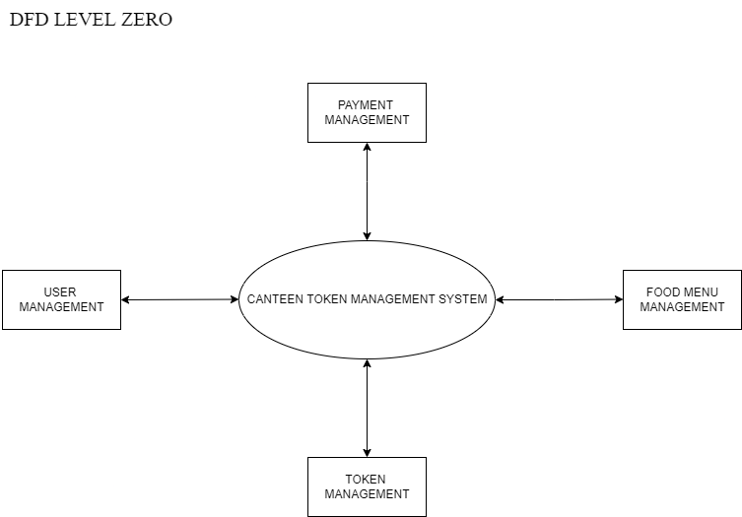

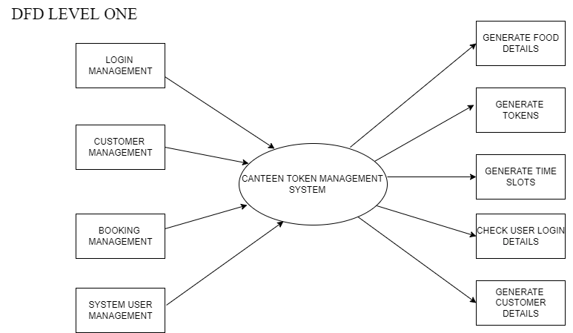

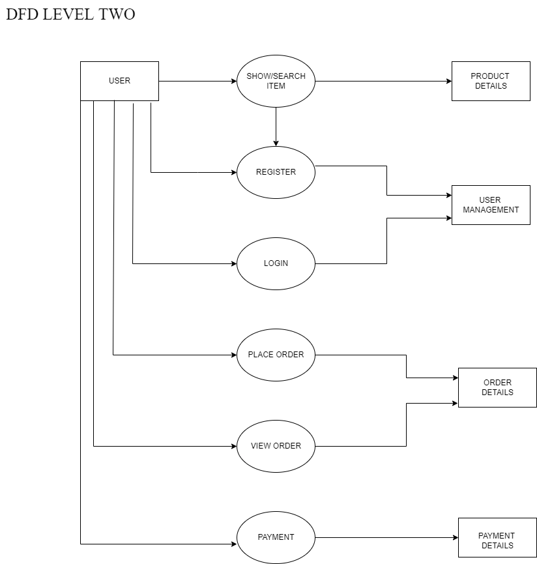
Fig 3.2: Data Flow Diagram

3.3 ACTIVITY DIAGRAM
An activity diagram visually presents a series of actions or flow of control in a system similar to a flowchart or a data flow diagram. Activity diagrams are often used in business process modeling. They can also describe the steps in a use case diagram. Activities modeled can be sequential and concurrent. In both cases an activity diagram will have a beginning (an initial state) and an end (a final state).The workflows from the activity diagram will serve as guide for system navigation in the final design phase of the system.

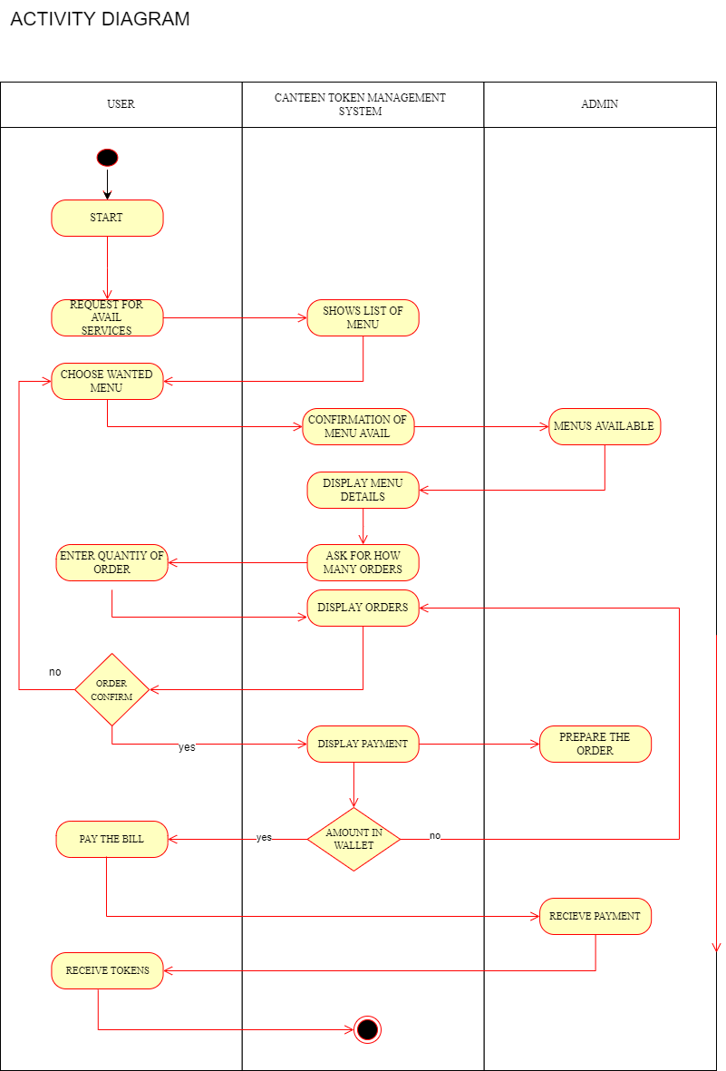
Fig 3.3: Activity Diagram

3.4 USE CASE DIAGRAM

It is a graphical depiction of a user’s possible interactions with a system. A use case diagram shows various use cases and different types of users the system has and will often be accompanied by other types of diagrams as well. The use cases are represented by either circle or ellipses. The actors are often shown as stick figures. While a use case itself might drill into a lot of detail about every possibility, a use case diagram can help provide a higher level view of the system. It has been said before that use case diagrams are blueprints of our system.

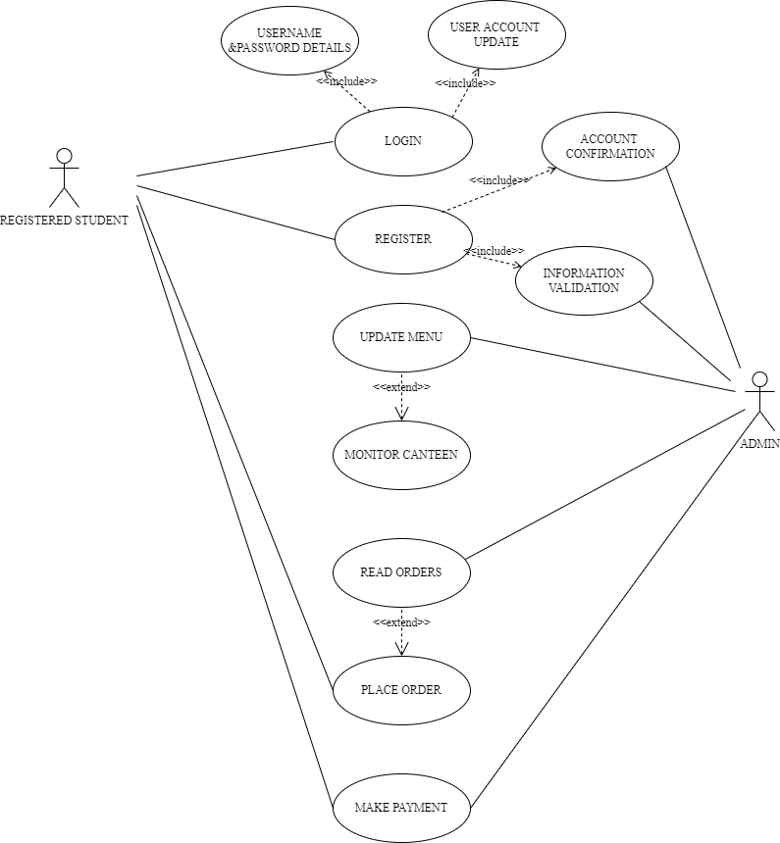

Fig 3.4: Use case Diagram

3.5 DATABASE DESIGN
Database Design is a collection of processes that facilitate the designing, development, implementation and maintenance of enterprise data management systems. Properly designed databases are easy to maintain, improve data consistency and are cost effective in terms of disk storage space. The database designer decides how the data elements correlate and what data must be stored.The main objectives of database design in DBMS are to produce logical and physical designs models of the proposed database system.
The logical model concentrates on the data requirements and the data to be stored independent of physical considerations. It does not concern itself with how the data will be stored or where it will be stored physically.The physical data design model involves translating the logical DB design of the database onto physical media using hardware resources and software systems such as database management systems (DBMS).

The main objectives behind database designing are to produce physical and logical design models of the proposed database system. To elaborate this, the logical model is primarily concentrated on the requirements of data and the considerations must be made in terms of monolithic considerations and hence the stored physical data must be stored independent of the physical conditions. On the other hand, the physical database design model includes a translation of the logical design model of the database by keeping control of physical media using hardware resources and software systems such as Database Management System (DBMS).
Database design is a method of identifying the gaps and opportunities of designing a proper utilization method. It is the main component of a system that gives a blueprint of the data and its behavior inside the system. A proper database design is always kept on priority due to the user requirements being kept excessively high and following up with the constraint practices of designing a database might only stand as a chance to gain the requested efficiency. Moreover, we also learned separately about the different design models that portray the ideal database design along with the limitless discussion on their properties and how to make use of them. Furthermore, we learned how the life-cycle of a database decides the design of the database and how to put the concept of design into the life-cycle methods so that efficient and highly sophisticated databases can be designed based on the user requirements.

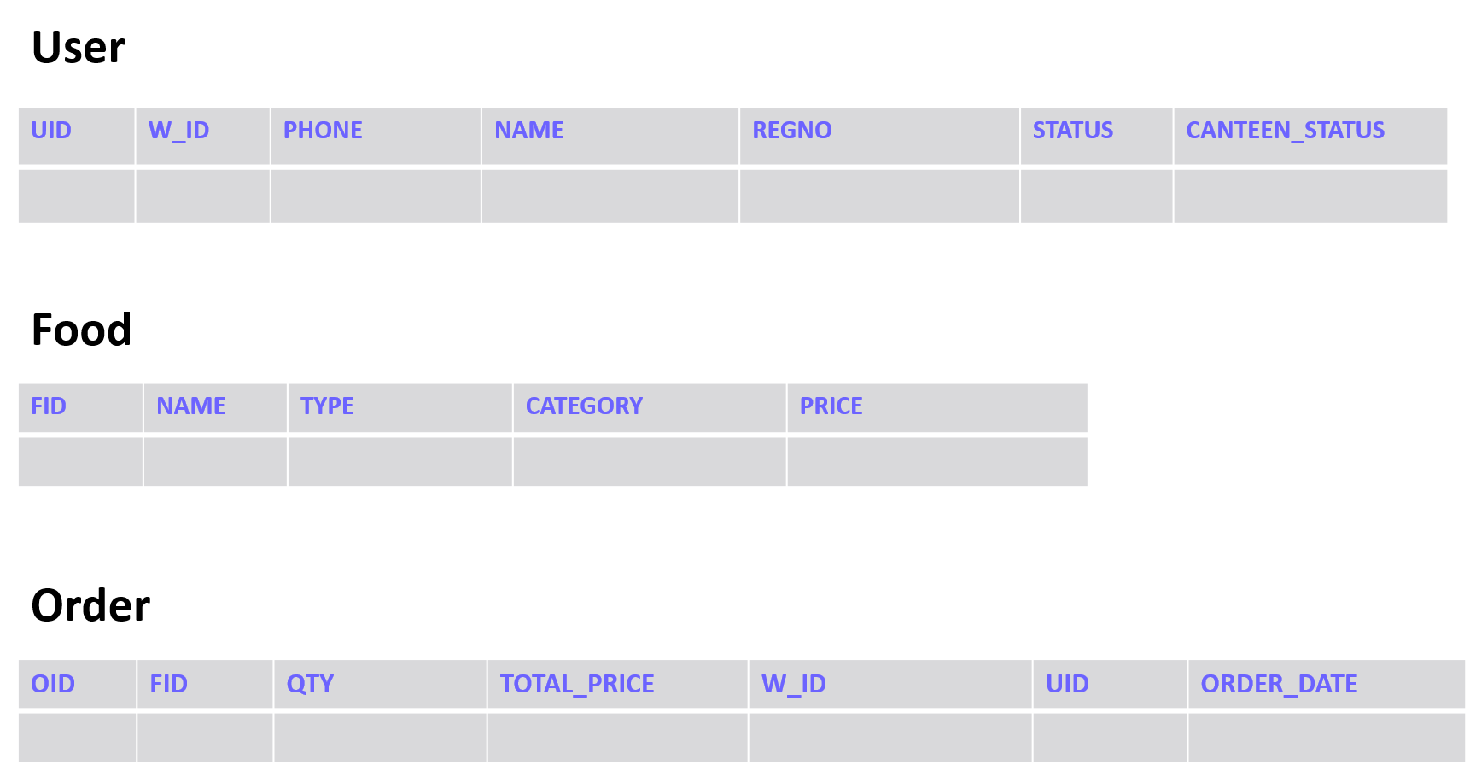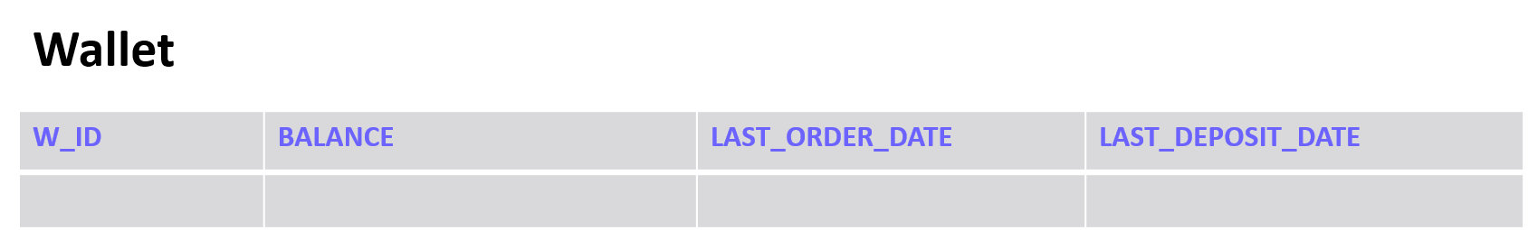
Fig 3.5: Database Design

CHAPTER 4

IMPLEMENTATION

Implementation is the stage in the project where the theoretical design is turned into a working system. The implementation phase constructs, installs and operates the new system. The most crucial stage in achieving a new successful system is that it will work efficiently and effectively.
If the user wants to access the canteen token management system application it is necessary to login successfully. After login, users can see the menu of the food,buy it. The user enters a username and password selects the corresponding identity (user or admin). If an ordinary user chooses the administrator, the system will prompt the user if the user does not exist, then the user cannot login,if the email id or password is wrong it will show an error message.

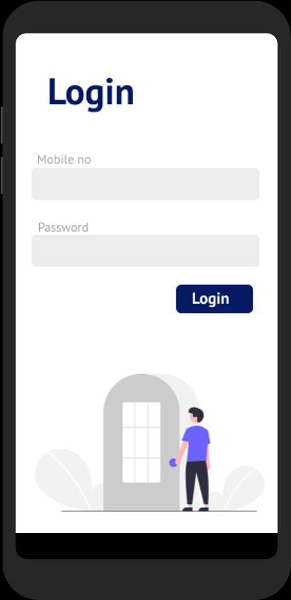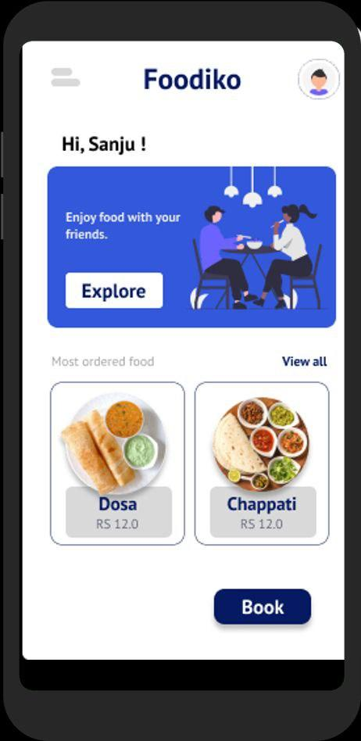

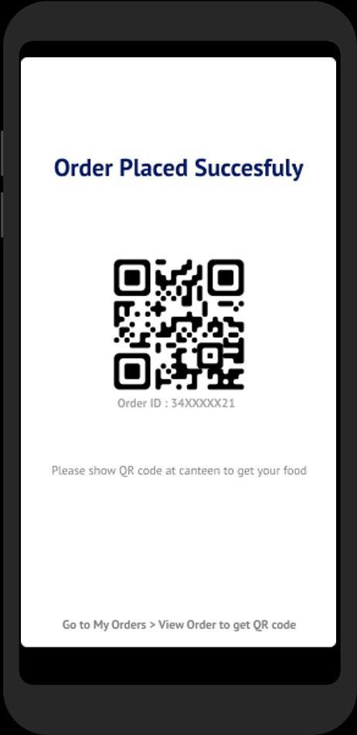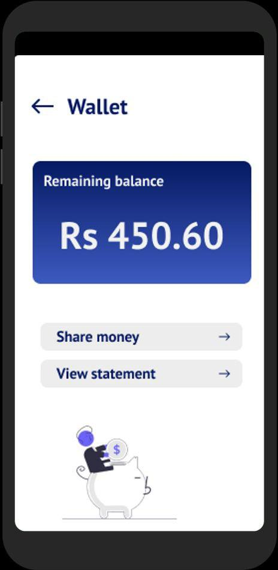

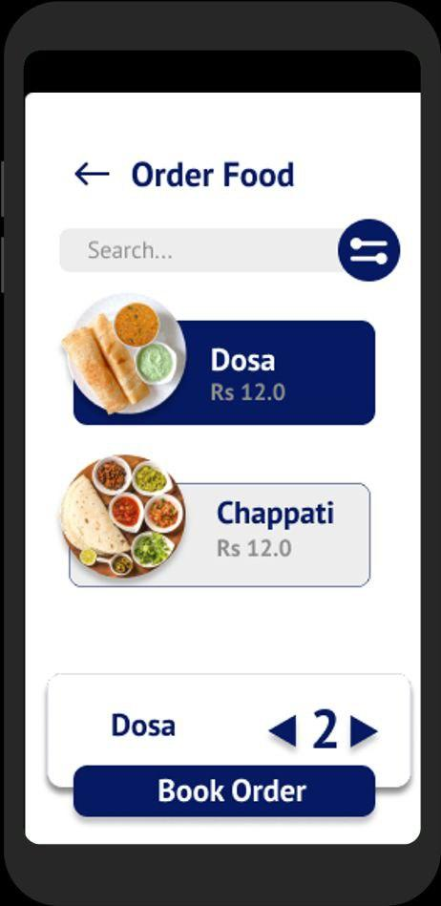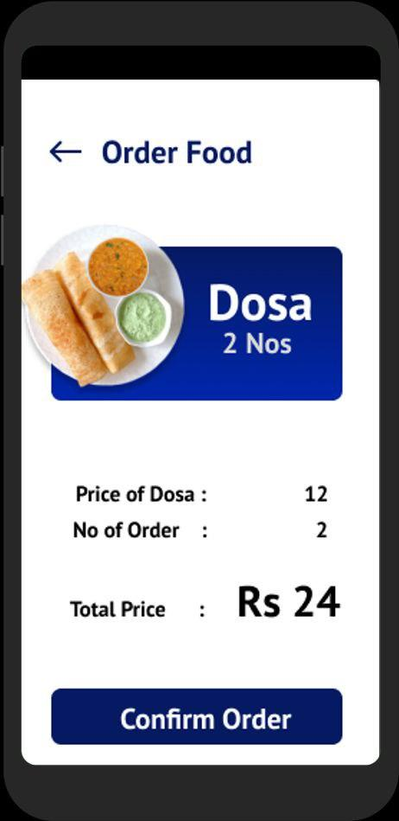
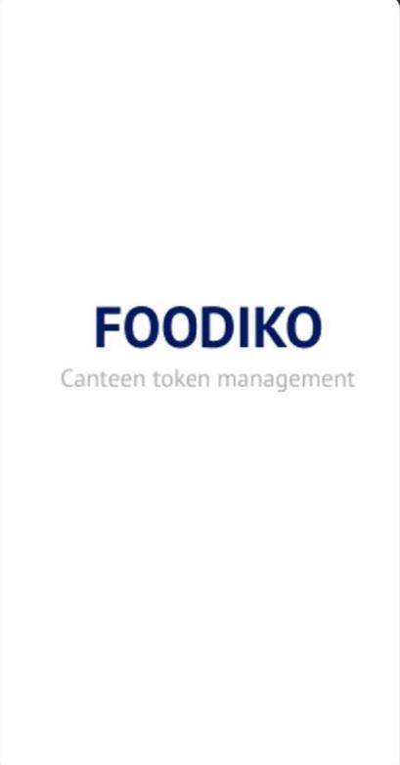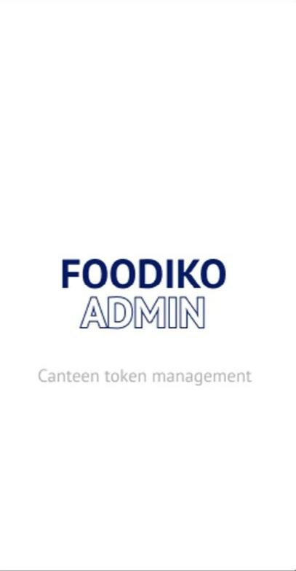

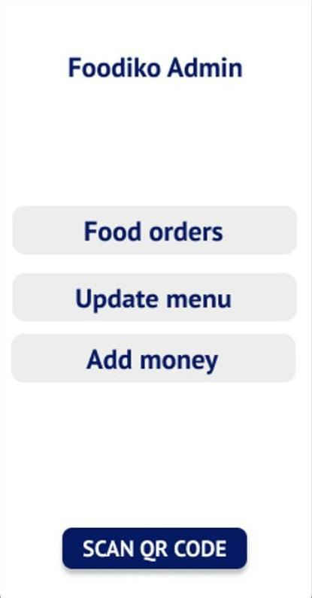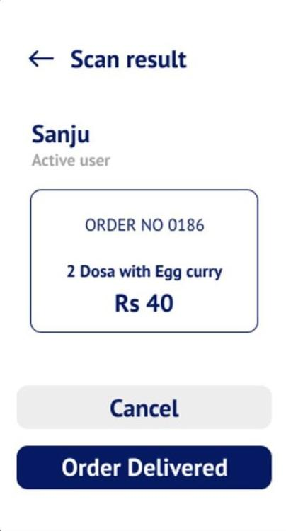

CHAPTER 5

RESULTS AND DISCUSSION

As per the objective of our project we were able to complete it more than 50%.We had created the front end of the system using flutter and it is almost completed.We were able to create user friendly user-interface which can be used by the user efficiently.Regarding the backend of the project we were able to create table for user,admin and driver which store the username and password.Register form is also created where the user can register for canteen token management system.The admin is also able to see the user details.

CHAPTER 6
CONCLUSION
The token management system used in Canteen is not only simple and easy but it also improves efficiency and reduces queues. The tokens are created by the Foodiko App by giving each student a limited number of tokens. When a student wants to buy something from the canteen, he/she uses one of their tokens for that purchase which is deducted from their total token balance. The new inventory will only be available when students use up their limit of tokens or if they come back to collect unused tokens before the deadline. With the help of this app we can reduce food waste as we can reduce the number of wasted packets going to waste by limiting the number of packs that a student is allowed to buy. The same system is used for buying juice or water and coffee. Besides reducing food waste, the app also reduces queues in canteen. It prevents students from waiting around at the canteen a long time and ensures their payment. We can also create queues, which will only be available after a certain amount of food is purchased by a student by issuing new tokens afterwards.

BIBLIOGRAPHY
WEBSITES

- www.google.com
- www.youtube.com
- www.geeksforgeeks.com
- www.javatpoint.com
- www.slideshare.net
- www.webpoint.com
- www.wikipedia.com

BOOKS

- Pankaj Jalote,”An approach to software engineering”,third edition,2005,Narosa publishing house
- Leon&Leon,”Database Management System”, Vikas Publishing House

